**EXP 2 EMPLOYEE DATABASE**

**Aim:**

Consider the employee database given below

**emp** (emp_id,emp_name, Street_No, city)

**works** (emp_id, company name, salary)

**company** (company name, city)

**manages** (emp_id, manager_id)+

**Note: Emp_id should start with ‘E’ in Emp table and emp_id in works table must be the emp_id from emp table .emp_id and manager_id in manages table must be the emp_id from emp table**

create table emp(emp_id varchar(5) check(emp_id like 'E%') primary key,emp_name varchar(25),street_no number, city varchar(25));

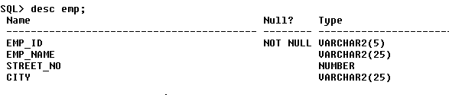

create table company(company_name varchar(25) primary key, city varchar(25));

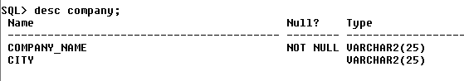

create table works(emp_id varchar(5) REFERENCES emp (emp_id), company_name varchar(25) REFERENCES company(company_name),salary number);

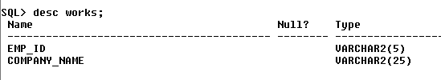

create table manages(emp_id varchar(5) REFERENCES emp(emp_id),manager_id varchar(5) REFERENCES emp(emp_id));

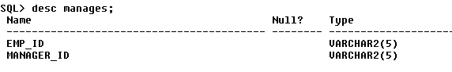

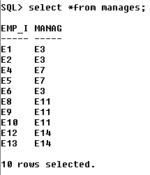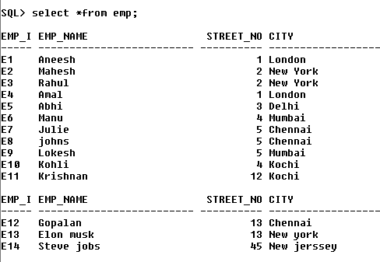

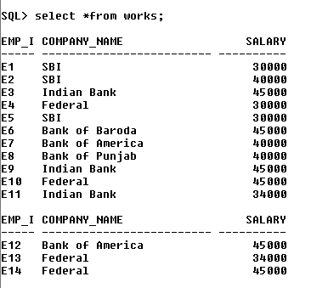

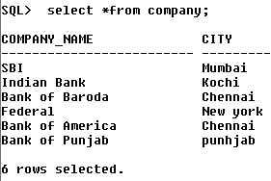

1. Find the names of all employees who work for SBI

select emp_name from emp inner join works on emp.emp_id = works.emp_id where company_name='SBI';

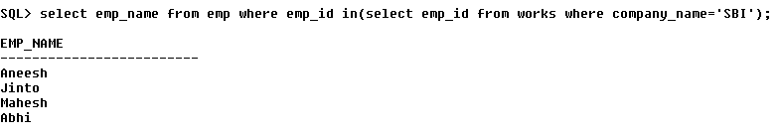

b. Find all employees in the database who live in the same cities as the companies for

which they work.

select emp_name from emp e,works w,company c where e.emp_id=w.emp_id and e.city=c.city and w.company_name=c.company_name;

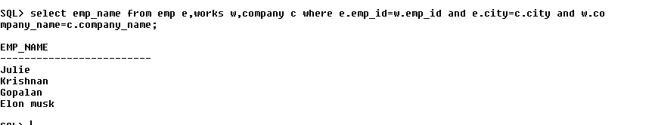

c. Find all employees who earn more than the average salary of all employees of their

company.

select emp_name from emp e,works w where e.emp_id=w.emp_id and w.salary>(select avg(salary) from works s where w.company_name=s.company_name);

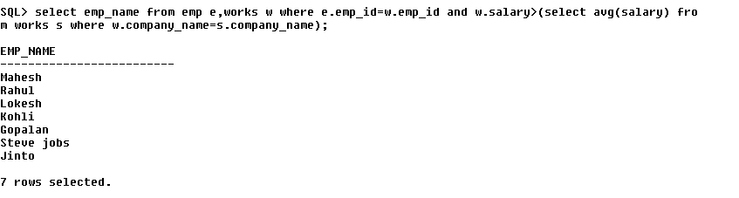

d. Give all managers of SBI a 10 percent raise.

update works w set salary=salary+salary*0.1 where company_name='sbi' and emp_id in(select manager_id from manages);

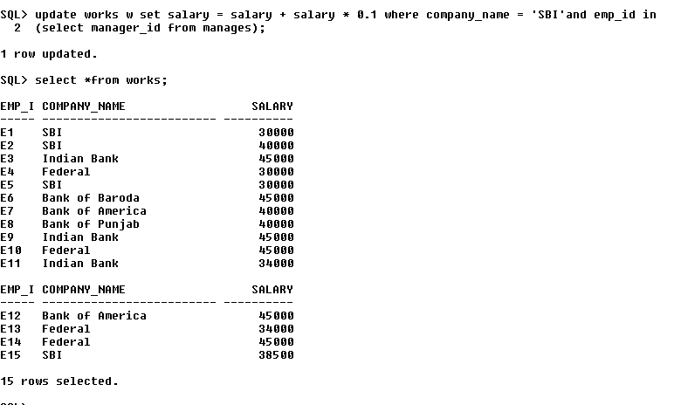

e. Find the company that has the most employees

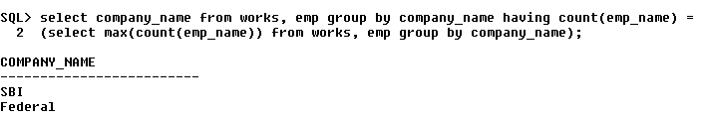

f. Find those companies whose employees earn a higher salary, on average than the

average salary at Indian Bank.

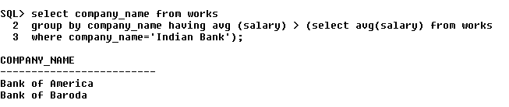

g. Query to find name and salary of all employees who earn more than each employee

of ‘Indian Bank’.

